**VPC Video-01**

* While launching the instance, the vpc id will match the new launch instance as well.

* Once instance launched, we can see instance Private IP and VPC IPV4, almost matches.
  + Launch screenshot below showing private IP.

* VPC IPV4 screenshot below.

**VPC Task-01**

1. **Create VPC with 2 private and 2 public subnets.**

* Created **VPC** below with CIDR range as**- 192.168.0.0/24.**
* **/24** is my **Subnet masking.**

* **Created 4 Subnets.**
* **2 Public Subnets-** Provided **IPV4 CIDR** rangesas **198.168.0.0/28** for **1st Public subnet** and **198.168.0.32** for **2nd Private subnet.**
* **2 Private Subnets-** Provided **IPV4 CIDR** ranges as **198.168.0.16/28** for **1st Private subnet** and **198.168.0.48** for **2nd Private subnet.**
* **Success-** VPC created and 4 subnets created.

1. **Enable DNS Hostname in VPC.**

* To enable **DNS Hostname** in VPC**-** Select created **VPC-** got to **Actions** and click **Edit VPC settings.**

* Then, click on **Enable DNS hostnames** and **save.**
* **Success-** DNS hostnames are enabled now.

1. **Enable Auto Assign Public IP in 2 public subnets.**

* To enable **Auto Assign Public IP-** select the **Subnet** and click **Actions** and select **Edit subnet settings.**
* Selected **1st Pub-sub1** andenabled **auto-assign public IPv4 address.**

* Selected **2nd Pub-sub2** andenabled **auto-assign public IPv4 address.**

1. **Add 2 private subnets in private route table.**

* Navigated to **Route Tables** and created one**,** where I just created and didn’t change anything.

* Added **2 pri-sub** in “**Subnet associations**”

* Added **2 private subnets** in **Private Route Table.**
* **Success-**Task completed.

1. **Add 2 public subnets in public route table.**

* We have already created **2 public subnets** and we need to create a **Internet Gateway to allow public route.**

* Now add the **Public subnets to the public route table.**

* Then finally we need to add the **public subnets** to the **public route table.**

1. **Public route table will have the routes to internet and local.**

* **IGW is** added to the **public route** in previous task**.**

* Now the **public route** will have access to the **public and local** as well.

* We created a **Encryption Control ID** and the **route table**s has beenassigned accordingly.

1. **Create EC2 in public subnet with t2.micro and install PHP.**

* Creating a new **ec2 instance** by adding few requirements**.**
* Selected AMI as **Linux** and Instance type **as t3.micro.** The question expectation is **t2.micro, whereas,** unfortunately, **t2.micro** is a paid service. So, selected **t3.micro.**
* Under **Network settings-** updated all requirements using **VPC, Subnets, Firewall** and **Security groups.**

* **Launched the instance.**

* Prior connecting to **ec-2 intance,** we updated the **Security groups** and added **“All traffic.**
* Connected to instance using **ssh user** command.

* Changed to **sudo and** used command**- yum update -y** to update the packages.

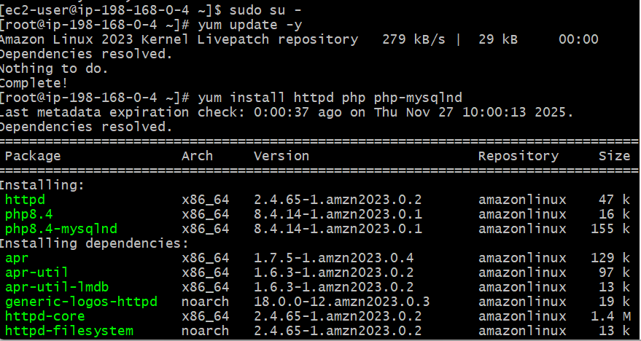

* Now, we need to **start the service** and check the **status.**

* **Success,** it works.

1. **Configure NAT gateway in public subnet and connect to private instance.**

* Created **NAT gateway** in **public subnet**.

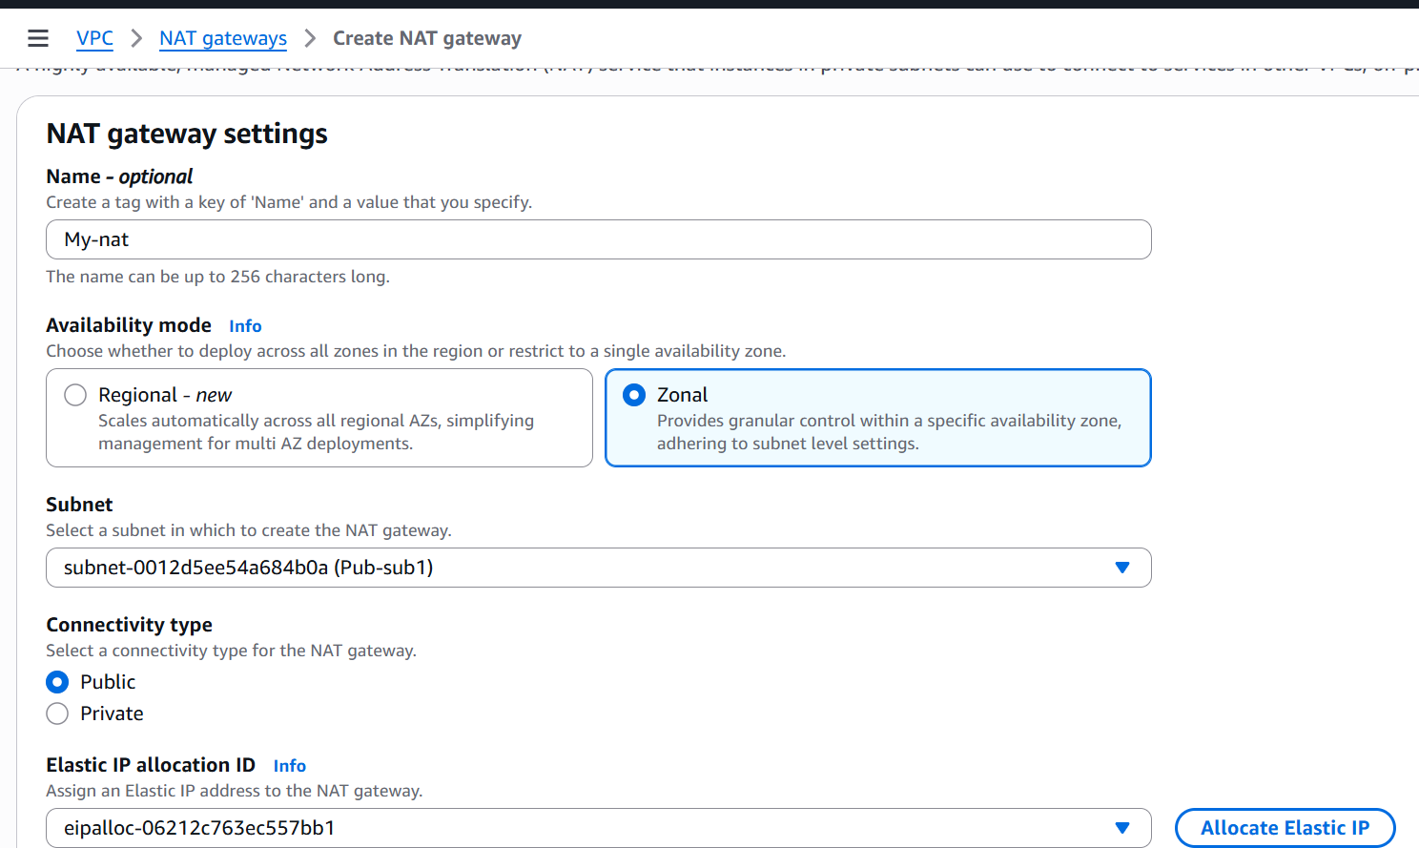

* Connected **Nat gateway** to **private route.**

* Launched the instance with **ec-2.**

* **Launched another Gitbash and copied ssh using command- Cat pem.key.**
* Copied and pasted the **ssh key** in **vi link.pem**
* Provided permission to the **link.pem.**
* Using **ssh -i link.pem ec2-user@private IP** of the instance.
* **Success-** Now the **private Instance** is connected inside **public Instance**.

* Using **ping google.com,** we confirmed the **IP** is connected to internet.

1. **Install Apache Tomcat in private EC2 and deploy a sample app.**

* Install Apache-Tomcat in Private EC2.
* Using **ssh -i vicky-1.pem ec2-user@publicipaddress**- launched the instance in Gitbash.
* Using **ssh -I link.pem ec2-user@privateipaddress**- launched the instance in same Gitbash. We **skipped the main work** to extracting pem.key ssh, where we completed the process in previous task.
* So, now we are going to install Apache-tomcat in Private EC2.

* Changed from Public to Private 🡪 **ssh -I link.pem ec2-user@privateipaddress**.

* **Update packages**

* Install **java** and install **apache-tomcat**

* Sudo systemctl enable tomcat9
* Sudo systemctl start tomcat9
* Sudo systemctl status tomcat9
* **Success**-Apache-tomcat is active and running.

* Deploy sample web app in tomcat- **cd /tmp**
* wget [https://tomcat.apache.org/tomcat-9.0 doc/appdev/sample/sample.war](https://tomcat.apache.org/tomcat-9.0%20doc/appdev/sample/sample.war)
* **sudo cp sample.war /var/lib/tomcat9/webapps/**

* Restart **Tomcat**
* **sudo systemctl restart tomcat9**
* **sudo systemctl status tomcat9**

* **Test deployment**: curl <http://localhost:8080/sample>
* **Output:** Welcome to Private Tomcat Server

* Testing NAT gateway Internet access: **ping google.com**
* **Success-** Task completed.

1. **Configure VPC flow logs and store the logs in S3 and CloudWatch.**

* Before creating flow logs in VPC.
* Searched Cloud Watch in search bar and navigated to Cloud Watch.
* Created a log group as **vpc-flow-logs**- under Log groups.

* Before creating flow logs in VPC.
* Searched S3 in search bar and navigated to S3.
* Created a log group as **vpc-flowlog-bucket-vignesh** under General Purpose Buckets.

* Created a **flow log in VPC** and attached destination from **Cloud Watch**.

* Created a **flow log in VPC** and attached destination from **S3.**

* Log stored in **Cloud Watch**.

* Log stored in **S3.**

